

**FNDB020 Accounting**

**Student Workbook**

**Lecture and Tutorial**

# Week 4: Adjustments (Part 1)

## Updated March 2018

# FNDB020 Lecture Week 4: The Accounting Cycle:

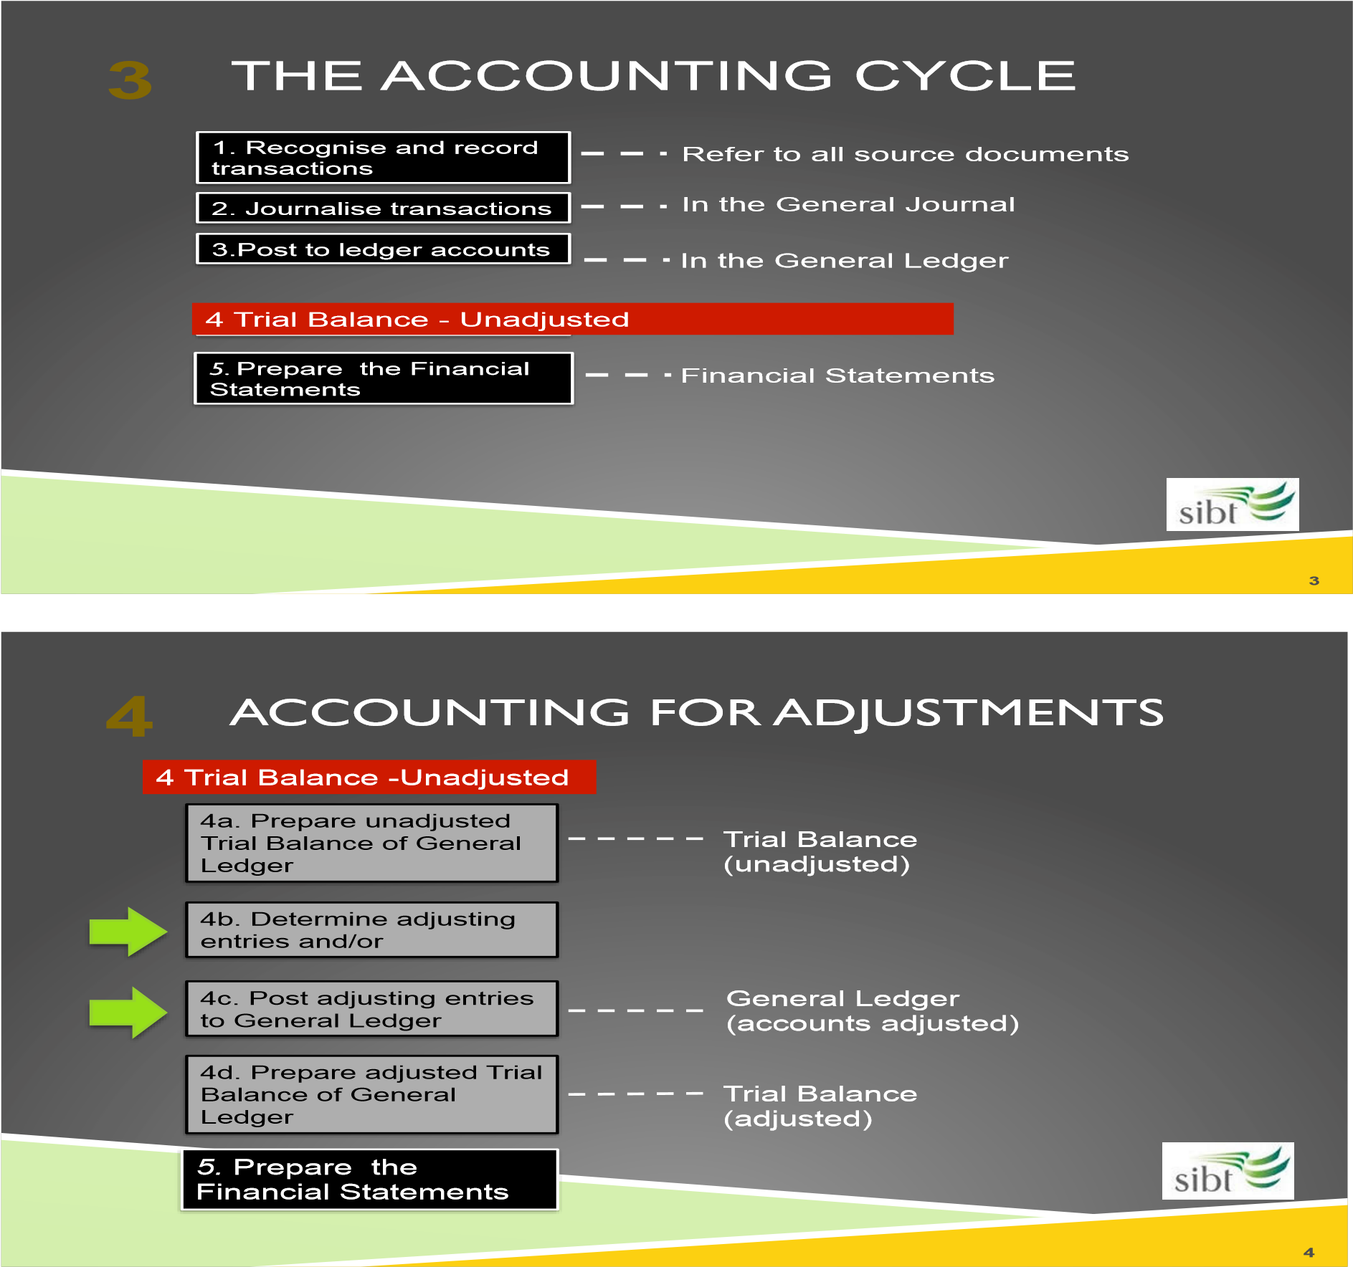

## Misleading Financial Statements

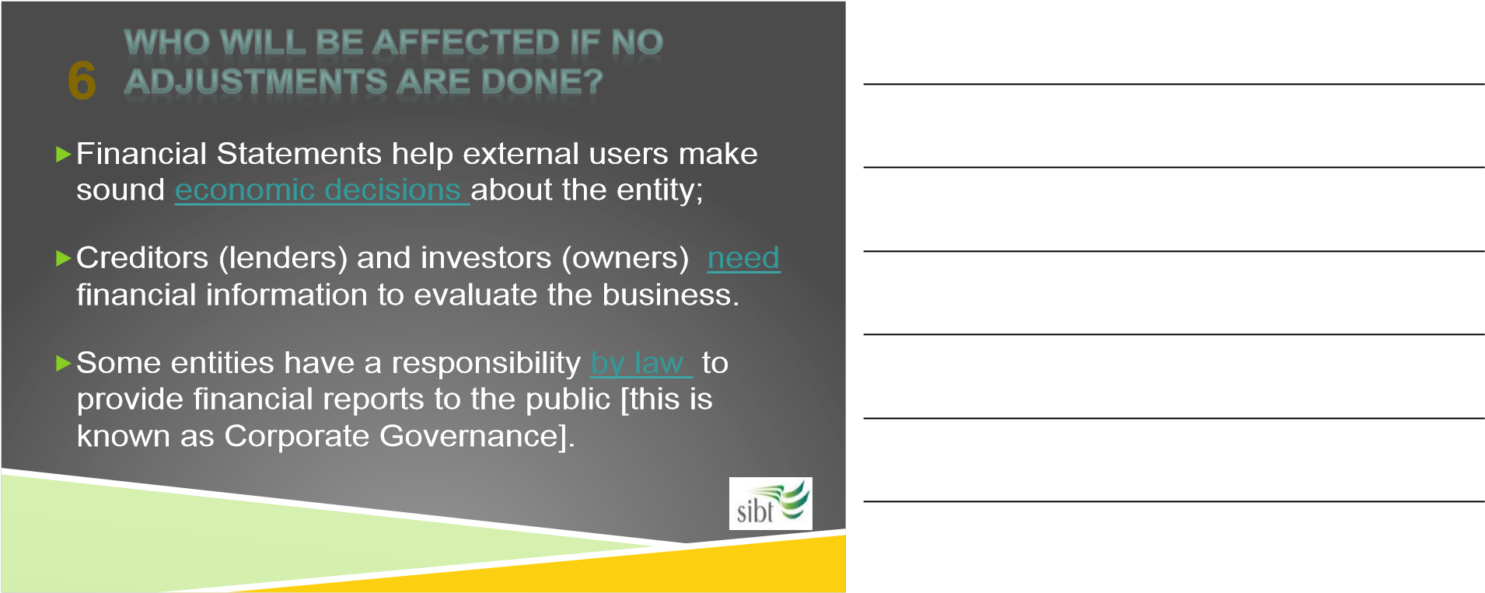

## Why do we need to adjust financial Statements?

Adjusting the financial statements to record the proper or accurate transaction is meant for several reasons:



## There are two ways to measure profit accurately:

1. **Cash-basis accounting**
2. **Accruals accounting**

## Why is accrual system more useful?

## Revisit definition of income and expenses

1. Income
2. Expenses

## Permanent and temporary accounts

* Temporary accounts are
* Permanent accounts

## Accounting Cycle

* Note the accounting cycle

## The need for the Adjusting process



Accruals accounting measures the

**performance**

and

**position**

of a business by:



matching

expenses to the time when income is

earned rather than when payment is made.



the matching principle can include both

cash

and

non-cash transactions

.

**7**

ADJUSTMENTS FOLLOW THE

ACCRUAL ACCOUNTING RULES

## The 4 types of Adjusting Entries

Prepayments

1. Prepaid expenses: amounts paid in cash and recorded as assets until the economic benefits are used or consumed.
2. Revenues received in *advance*: amounts received from customers and recorded as liabilities until the services are performed or the goods provided.

Accruals

1. Accrued revenues: amounts not yet received and not yet recorded for which the goods or services have been provided.
2. Accrued expenses: amounts not yet paid and not yet recorded for which the consumption of economic benefit has occurred.

## Prepaid Expenses

1. Prepaid expenses: amounts paid in cash and recorded as assets until the economic benefits are used or consumed.

## PREPAYMENTS: Prepaid Expense

Date 1st February Adele paid $3,000 for 5 months of Supplies. She estimates that she consumes $600 worth of supplies each month. Complete the adjustment entry required at the 30 June

|  |  |  |  |
| --- | --- | --- | --- |
| Date | Assets | liabilities | Owner equity |
| 1/2 |  |  |  |
| 30/6 |  |  |  |

|  |  |  |  |
| --- | --- | --- | --- |
| Date | Accounts effected | Debit | Credit |
| 1/2 |  |  |  |
|  |  |  |  |
|  |  |  |  |
| 30/6 |  |  |  |
|  |  |  |  |
|  |  |  |  |

|  |  |  |  |  |  |  |  |  |
| --- | --- | --- | --- | --- | --- | --- | --- | --- |
| dr |  | | cr |  | dr |  | | cr |
|  |  |  |  |  |  |  |  |  |
|  |  |  |  |  |  |  |  |  |
|  |  |  |  |  |  |  |  |  |
|  |  |  |  |  |  |  |  |  |

## Prepaid Insurance expense

On 1st March Adele paid $2,400 for Insurance premium for 1 year. How much has been used up by 30/6? Record the adjustment entry at the 30 June

|  |  |  |  |
| --- | --- | --- | --- |
| Date | Assets | liabilities | Owner equity |
| 1/3 |  |  |  |
| 30/6 |  |  |  |

|  |  |  |  |
| --- | --- | --- | --- |
| Date | Accounts effected | Debit | Credit |
| 1/3 |  |  |  |
|  |  |  |  |
|  |  |  |  |
| 30/6 |  |  |  |
|  |  |  |  |
|  |  |  |  |

|  |  |  |  |  |  |  |  |  |
| --- | --- | --- | --- | --- | --- | --- | --- | --- |
| dr |  | | cr |  | dr |  | | cr |
|  |  |  |  |  |  |  |  |  |
|  |  |  |  |  |  |  |  |  |
|  |  |  |  |  |  |  |  |  |
|  |  |  |  |  |  |  |  |  |

## 

## **Accrual expenses**

• Expenses (for the current accounting period) not yet paid or recorded at balance date are called accrued expenses. Rent, salaries and interest are common examples.

1. **At 30 June Adele owes $700 in wages to her part time administration assistant. This was for work completed for a few weeks in early June.**

|  |  |  |  |
| --- | --- | --- | --- |
| Date | Assets | liabilities | Owner equity |
| 30/6 |  |  |  |

|  |  |  |  |
| --- | --- | --- | --- |
| Date | Accounts effected | Debit | Credit |
|  |  |  |  |
|  |  |  |  |
|  |  |  |  |
|  |  |  |  |
|  |  |  |  |
|  |  |  |  |

|  |  |  |  |  |  |  |  |  |
| --- | --- | --- | --- | --- | --- | --- | --- | --- |
| dr |  | | cr |  | dr |  | | cr |
|  |  |  |  |  |  |  |  |  |
|  |  |  |  |  |  |  |  |  |

1. **Adele took a small loan from the bank. She owes $600 bank interest at balance date.**

|  |  |  |  |
| --- | --- | --- | --- |
| Date | Assets | liabilities | Owner equity |
| 30/6 |  |  |  |

|  |  |  |  |
| --- | --- | --- | --- |
| Date | Accounts effected | Debit | Credit |
|  |  |  |  |
|  |  |  |  |
|  |  |  |  |
|  |  |  |  |
|  |  |  |  |
|  |  |  |  |

|  |  |  |  |  |  |  |  |  |
| --- | --- | --- | --- | --- | --- | --- | --- | --- |
| dr |  | | cr |  | dr |  | | cr |
|  |  |  |  |  |  |  |  |  |
|  |  |  |  |  |  |  |  |  |

## Prepaid income (or unearned Income)

## Revenues collected in advance, but not yet earned

## e.g. magazine subscription received in advance

**On 1st April Adele received $6,300 cash to design a landscape garden for a new block of apartments. Adele submits 1 of the 3-part design plan in June.**

**How will Adele record services completed as at balance date 30 June:**

|  |  |  |  |
| --- | --- | --- | --- |
| Date | Assets | liabilities | Owner equity |
|  |  |  |  |
|  |  |  |  |

General Journal

|  |  |  |  |
| --- | --- | --- | --- |
| Date | Accounts effected | Debit | Credit |
|  |  |  |  |
|  |  |  |  |
|  |  |  |  |
|  |  |  |  |
|  |  |  |  |
|  |  |  |  |

General Ledger

|  |  |  |  |  |  |  |  |  |
| --- | --- | --- | --- | --- | --- | --- | --- | --- |
| dr |  | | cr |  | dr |  | | cr |
|  |  |  |  |  |  |  |  |  |
|  |  |  |  |  |  |  |  |  |

|  |  |  |  |  |  |  |  |  |
| --- | --- | --- | --- | --- | --- | --- | --- | --- |
| dr |  | | cr |  | dr |  | | cr |
|  |  |  |  |  |  |  |  |  |
|  |  |  |  |  |  |  |  |  |

## Accrued income

Revenues earned, but not yet received in cash or recorded in the Accounting system

e.g. interest earned on a bank term deposit but not received from the bank

**On 1st May Adele was promised 5% Commission on Sales from introducing her client to the Nursery. The Nursery sold $6,000 of plants to the new Client in June.**

**How will Adele record this Commission at balance date 30 June?**

|  |  |  |  |
| --- | --- | --- | --- |
| Date | Assets | liabilities | Owner equity |
|  |  |  |  |

General Journal

|  |  |  |  |
| --- | --- | --- | --- |
| Date | Accounts effected | Debit | Credit |
|  |  |  |  |
|  |  |  |  |
|  |  |  |  |

General Ledger

|  |  |  |  |  |  |  |  |  |
| --- | --- | --- | --- | --- | --- | --- | --- | --- |
| dr |  | | cr |  | dr |  | | cr |
|  |  |  |  |  |  |  |  |  |
|  |  |  |  |  |  |  |  |  |

## Depreciation of Non current assets

Similar to prepaid expense where we need to record the cost of using the asset in the current accounting period.

On 1st April Garden Design paid $5,000 for Office Equipment. This includes an Architect’s desk, drafting chair, filing cabinets to help set up owner Adele start her business.

**Additional information given is**: the **useful life** of the asset is 5 years and Adele believes that the asset will have **no** scrap value after 5 years (= $0).

**Adjustment** to Office Equipment at balance date on 30 June:

Office Equipment is a non-current asset with a **useful life** for *many years* in the business (providing future economic benefit > 1 year). This non-current asset or *long-lived* asset is essentially similar to a long-term prepayment of future economic benefits. Like other prepaid assets it will be expensed (for non-current assets, expense = ‘depreciation’) to recognise the future benefits consumed during each financial period.

The **adjustment** for depreciating a long-term/non-current asset is done on the last day or the financial year-end (balance date). The value to be depreciated on balance date is based on a formula:

* Depreciation expense for a full financial year is calculated as:

𝐶𝑜𝑠𝑡−𝑆𝑐𝑟𝑎𝑝 𝑉𝑎𝑙𝑢𝑒

𝐷𝑒𝑝𝑟𝑒𝑐𝑖𝑎𝑡𝑖𝑜𝑛 𝐸𝑥𝑝𝑒𝑛𝑠𝑒 1 𝑦𝑒𝑎𝑟 =

𝑈𝑠𝑒𝑓𝑢𝑙 𝑙𝑖𝑓𝑒

**Useful life** – how long (in years) the asset will be used in the business.

**Scrap value** – how much ($) the business expects to receive when it sells (disposes) the asset at the end of its useful life. Sometimes, the scrap value can be zero.

*Note: Depreciation* applies to other (long-lived) assets like building, motor vehicles, fixtures & fittings.

## Depreciation task

For Adele, Office Equipment was purchased for $5,000 cash with a useful life of 5 years and $0 scrap value. Record the purchase of the asset at 1/4 and the Depreciation expense at 30/6

|  |  |  |  |
| --- | --- | --- | --- |
| Date | Assets | liabilities | Owner equity |
| 1/4 |  |  |  |
| 30/6 |  |  |  |

General Journal

|  |  |  |  |
| --- | --- | --- | --- |
| Date | Accounts effected | Debit | Credit |
|  |  |  |  |
|  |  |  |  |
|  |  |  |  |
|  |  |  |  |
|  |  |  |  |
|  |  |  |  |
|  |  |  |  |

General Ledger

|  |  |  |  |  |  |  |  |  |
| --- | --- | --- | --- | --- | --- | --- | --- | --- |
| dr |  | | cr |  | dr |  | | cr |
|  |  |  |  |  |  |  |  |  |
|  |  |  |  |  |  |  |  |  |
| dr |  | | cr |  | dr |  | | cr |
|  |  |  |  |  |  |  |  |  |
|  |  |  |  |  |  |  |  |  |

## Adjusted Trial Balance

## Unadjusted trial balance used as starting point

## Adjusting entries are posted from Gen Journal to the general ledger

## An adjusted trial balance can then be prepared

## Debits = credits

## Adjusting entries always affect an Income Statement and a Balance Sheet account

## Practice Question: Putting it all together

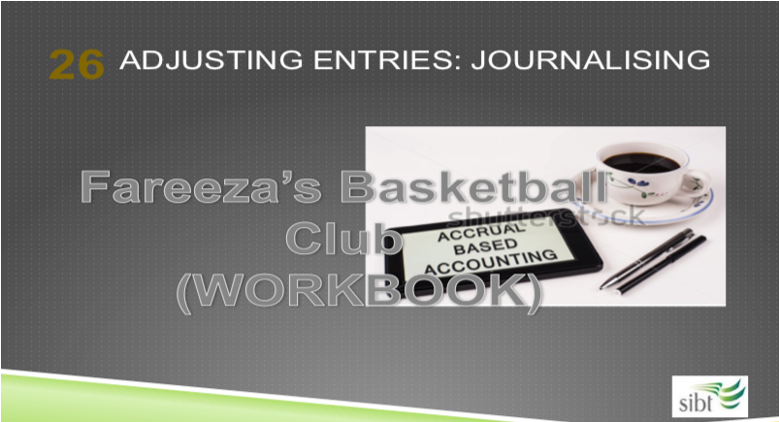

The following information relates to Fareeza’s Basketball Club for the year ended 30 June 2017 (balance date):

**Business Transaction**

1. Prepaid rent expired during the year, $6,000.

1. Depreciation on Sports Equipment was $3,000 for the year
2. Electricity expenses of $550 were unpaid at year end (i.e. balance date)

1. Supplies purchased during the year totalled $800. At year end, only $150 of supplies remained on hand
2. Interest of $320 had been earned on an investment, but cash has not been received.

1. Unpaid Wages at year end amounted to $5,000.
2. Cash of $8,000 had been received in advance for Basketball Camps to be held in the future. This was recorded as Unearned Revenue. By year end all the revenue had been earned.

Prepare the necessary **adjusting entries** in the general journal entries on balance date 30 June 2017.

**General Journal (exam format):**

|  |  |  |  |
| --- | --- | --- | --- |
| **Date** | **Details** | **Debit** | **Credit** |
|  |  |  |  |
|  |  |  |  |
|  |  |  |  |
|  |  |  |  |
|  |  |  |  |
|  |  |  |  |
|  |  |  |  |
|  |  |  |  |
|  |  |  |  |
|  |  |  |  |
|  |  |  |  |
|  |  |  |  |
|  |  |  |  |
|  |  |  |  |
|  |  |  |  |
|  |  |  |  |
|  |  |  |  |
|  |  |  |  |
|  |  |  |  |
|  |  |  |  |
|  |  |  |  |
|  |  |  |  |
|  |  |  |  |

Tutorial Week 4

## Task 1

The following is information for adjustments at 30 June 2016:

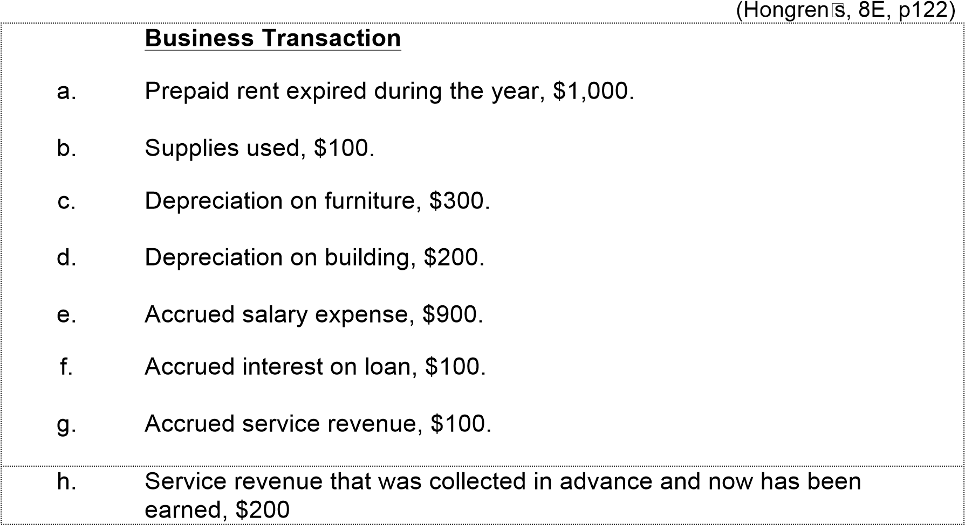

**Required:**

Prepare the necessary **adjusting entries** in the general journal.

|  |  |  |  |
| --- | --- | --- | --- |
| **Date** | **Details** | **Debit** | **Credit** |
|  |  |  |  |
|  |  |  |  |
|  |  |  |  |
|  |  |  |  |
|  |  |  |  |
|  |  |  |  |
|  |  |  |  |
|  |  |  |  |
|  |  |  |  |
|  |  |  |  |
|  |  |  |  |
|  |  |  |  |
|  |  |  |  |
|  |  |  |  |
|  |  |  |  |
|  |  |  |  |
|  |  |  |  |
|  |  |  |  |
|  |  |  |  |
|  |  |  |  |
|  |  |  |  |
|  |  |  |  |
|  |  |  |  |

|  |
| --- |
| **Exercise 3.7** |

#### 

|  |
| --- |
| **Exercise 3.10** |

#### **Recording transactions general ledger [Part B Only]**

*In December 2016, the following transactions occurred in Macchiato’s Coffee Roasters business that supplies cafés and also sells direct to the public:*

***Dec***

***2*** *Michael Macchiato invested $2 650 000 into the business of Macchiato’s Coffee Roasters by purchasing a fully equipped coffee roasting business. The business acquired consisted of the following assets and liabilities:*

*Land $1 200 000*

*Building 1 000 000*

*Coffee roasting equipment 420 000*

*Office equipment 60 000*

*Accounts payable 30 000*

1. *Purchased some new roasting equipment on credit for $160 000.*
2. *Collected cash from customers for the month, $220 000.*

***12*** *Paid the accounts payable owing on 2 December when Michael purchased the business.*

***14*** *Purchased an insurance policy for the year for $6000 cash.*

***18*** *Purchased television advertising for the Christmas period for $8000 to be paid for in 30 days.*

***23*** *Collected fees in cash from customers for the Christmas period, amounting to 23 $46 000.*

***30***  *Michael withdrew $8000 cash in order to pay for private Christmas presents and parties.*

##### Required

1. *Prepare* ***general journal*** *entries for each of the above transactions and events.* DONE Week 3 see next page
2. *Post the entries to* ***ledger T*** *accounts and balance the accounts as at 31 December 2016. TODAY’s Exercise.*

**A. *[Part A was completed in WEEK 3. This is included for reference purposes]***

## Update your glossary

## Do Kahoot Week 4

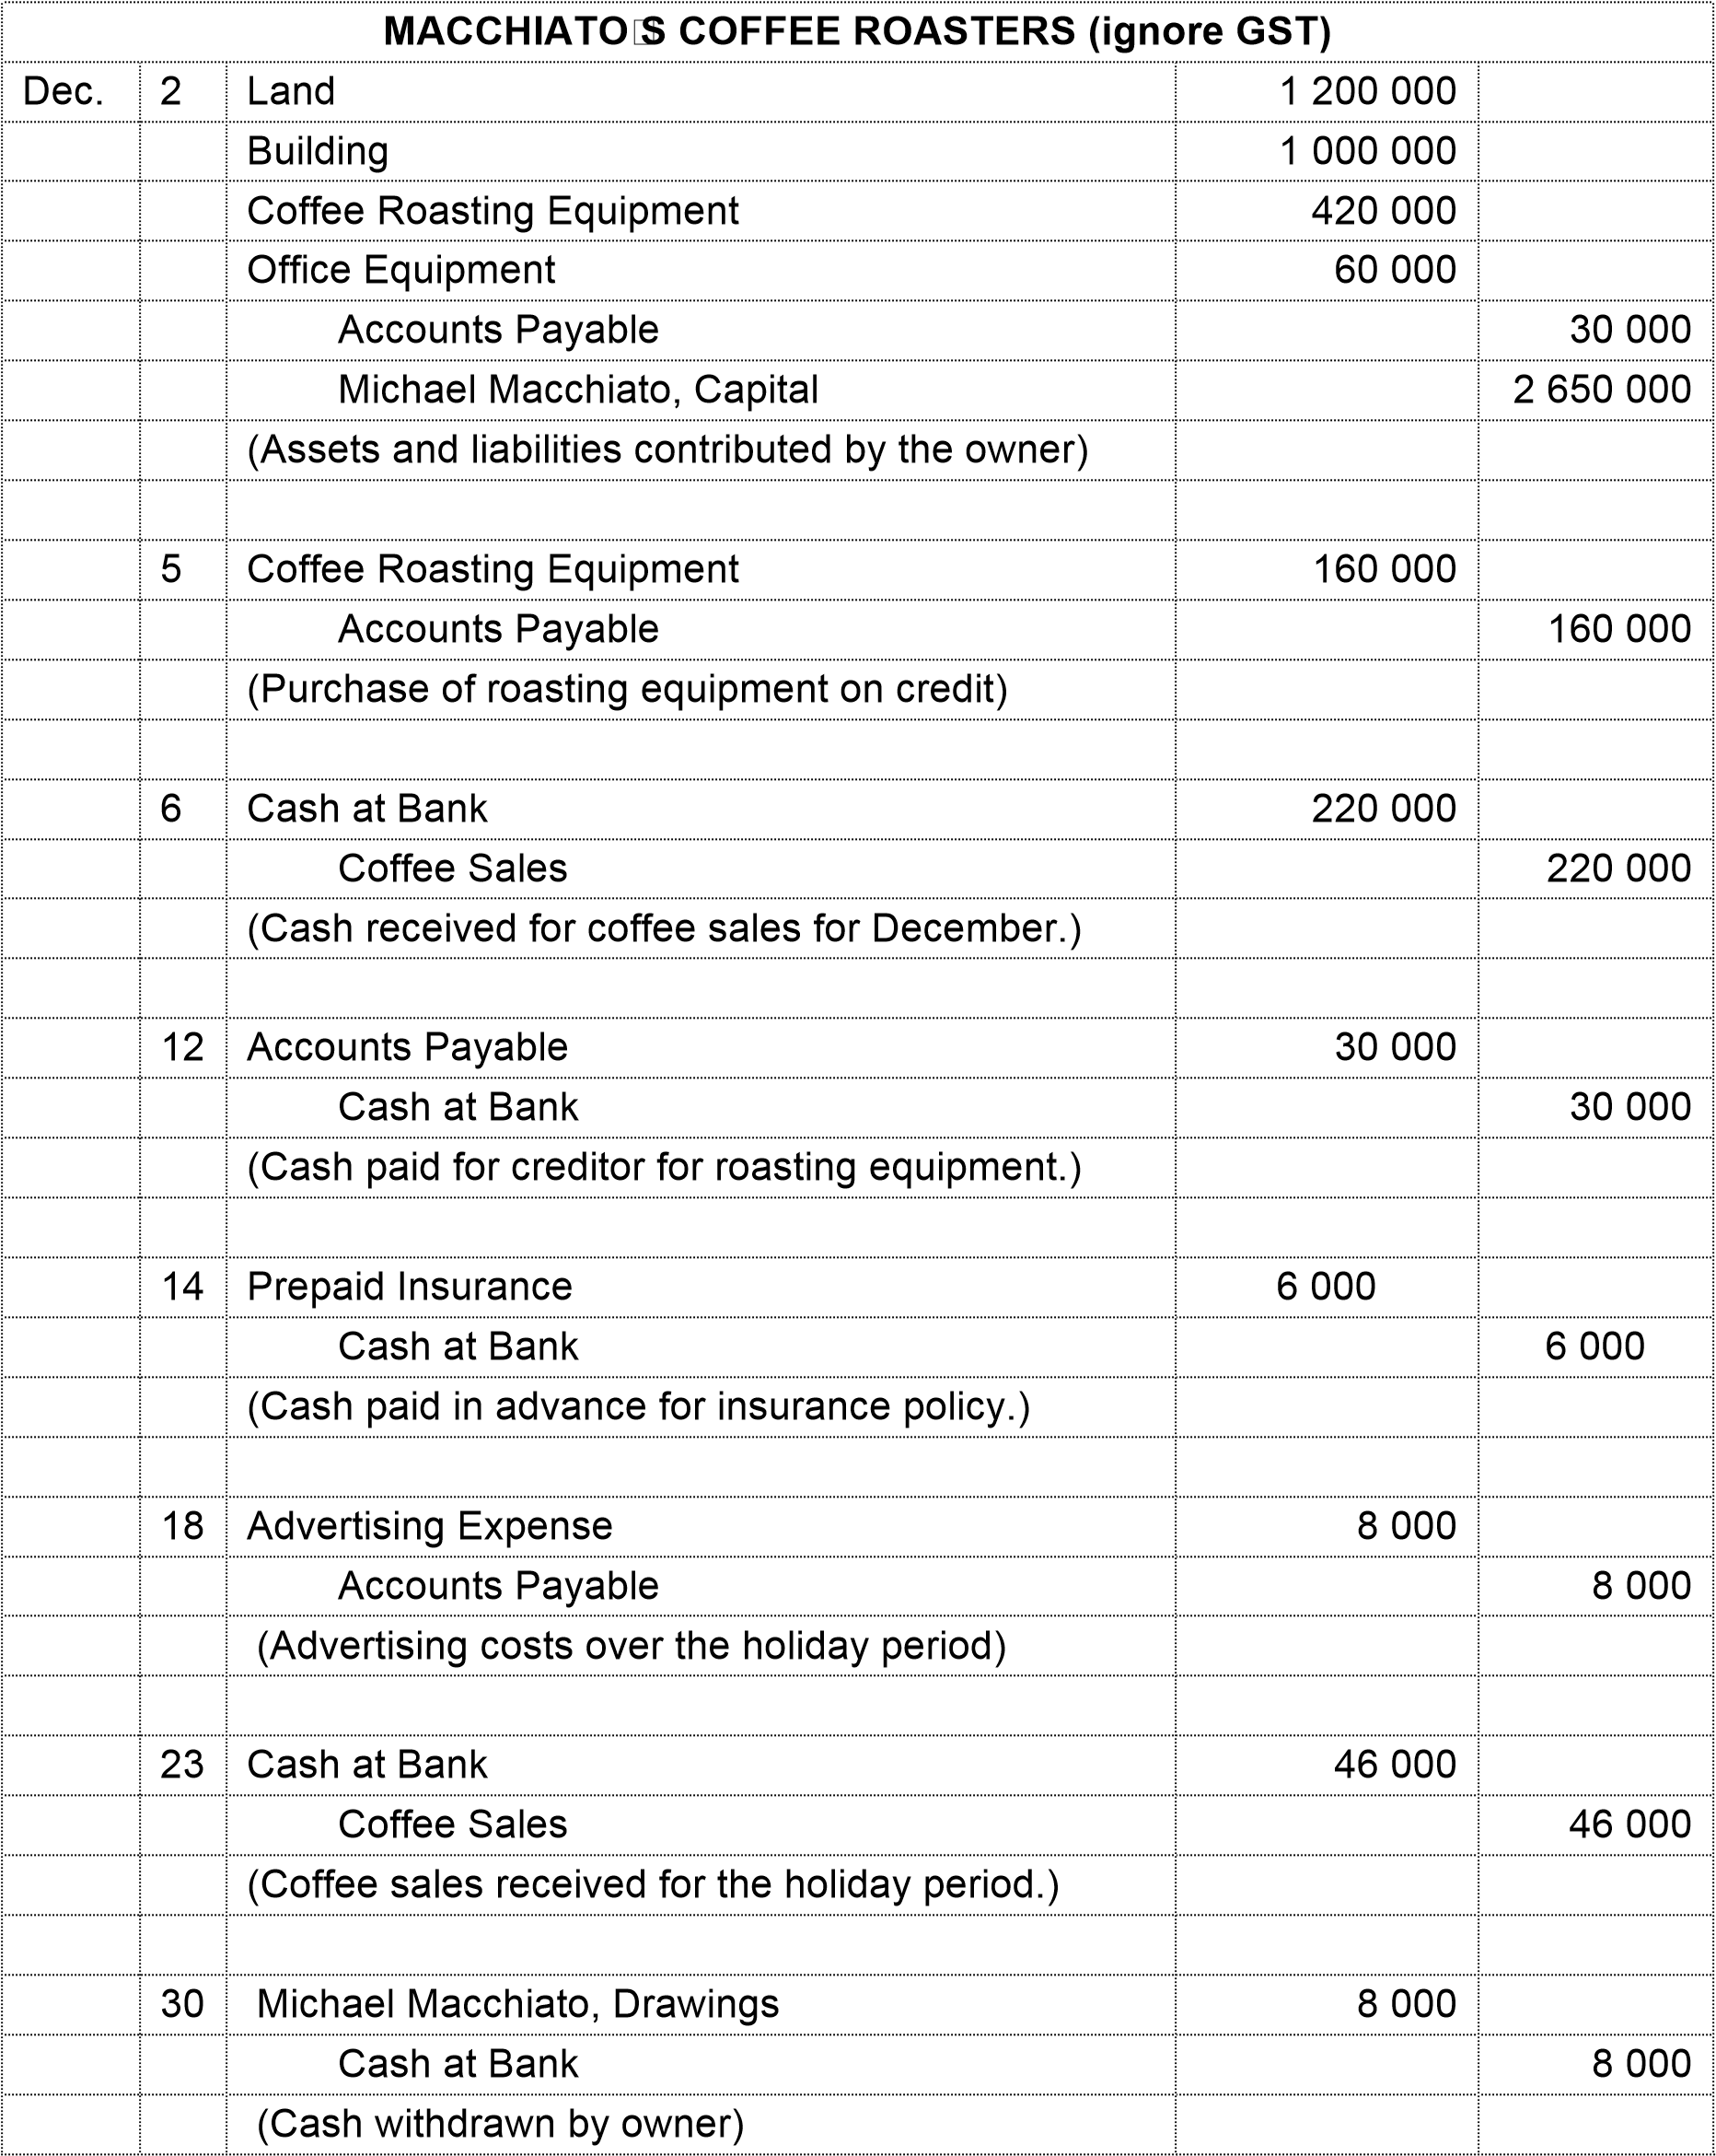

|  |  |  |  |  |  |  |  |  |
| --- | --- | --- | --- | --- | --- | --- | --- | --- |
| Dr | Cash at Bank | | Cr |  | Dr | Capital | | Cr |
|  |  |  |  |  |  |  |  |  |
|  |  |  |  |  |  |  |  |  |
|  |  |  |  |  |  |  |  |  |
|  |  |  |  |  |  |  |  |  |
|  |  |  |  |  |  |  |  |  |
|  |  |  |  |  |  |  |  |  |
|  |  |  |  |  |  |  |  |  |
| Dr |  | | Cr |  | Dr |  | | Cr |
|  |  |  |  |  |  |  |  |  |
|  |  |  |  |  |  |  |  |  |
|  |  |  |  |  |  |  |  |  |
|  |  |  |  |  |  |  |  |  |
| Dr |  | | Cr |  | Dr |  | | Cr |
|  |  |  |  |  |  |  |  |  |
|  |  |  |  |  |  |  |  |  |
|  |  |  |  |  |  |  |  |  |
|  |  |  |  |  |  |  |  |  |
| Dr |  | | Cr |  | Dr |  | | Cr |
|  |  |  |  |  |  |  |  |  |
|  |  |  |  |  |  |  |  |  |
|  |  |  |  |  |  |  |  |  |
|  |  |  |  |  |  |  |  |  |
| Dr |  | | Cr |  | Dr |  | | Cr |
|  |  |  |  |  |  |  |  |  |
|  |  |  |  |  |  |  |  |  |
|  |  |  |  |  |  |  |  |  |
|  |  |  |  |  |  |  |  |  |
|  |  |  |  |  |  |  |  |  |
| Dr |  | | Cr |  | Dr |  | | Cr |
|  |  |  |  |  |  |  |  |  |
|  |  |  |  |  |  |  |  |  |
|  |  |  |  |  |  |  |  |  |
|  |  |  |  |  |  |  |  |  |
| Dr |  | | Cr |  | Dr |  | | Cr |
|  |  |  |  |  |  |  |  |  |
|  |  |  |  |  |  |  |  |  |
|  |  |  |  |  |  |  |  |  |
|  |  |  |  |  |  |  |  |  |

|  |
| --- |
| **Problem 3.9** |

##### Journal entries, T accounts and trial balance

COMPLETE BEFORE YOUR TUTORIALS

*Q3. During the year, the publishers of* Fishing for the Family*, a monthly magazine, received cash for a 3-year magazine subscription. A credit was made to the Unearned Subscriptions Revenue account.*

1. *Is the required adjusting entry made at the end of the period an example of accrual or a prepayment?*
2. *What types of accounts will be affected by the required adjusting entry?*
3. *What effect will omission of the adjusting entry have on profit and on the statement of financial position?*

|  |  |  |  |  |
| --- | --- | --- | --- | --- |
| **Exercise 4.3** |  | **Cash versus accrual accounting** |  |  |

*1. During March, Thuy Bui’s business performed services for a specific customer for which the fee was $9000. Payment was received in the following April.*

*(a) Was the revenue earned in March or April?*

*(b) What account should be debited in (i) March and (ii) April?*

*2. During the month a business received $160 000 in cash and paid out $120 000 in cash. Does this indicate that the business earned $40 000 during the month? Explain.*

*3. Gorajek Sole Traders purchased a 3-year insurance contract on 1 March. The business debited the entire cost of $12 000 to Insurance Expense. The financial year ends on 30 June. Under the accrual system, what is the correct expense for the current year, and what entry would be made to correct the accounts? Under the cash basis of accounting, what is the correct expense and the correct adjusting entry (if any)?*

|  |  |  |  |  |
| --- | --- | --- | --- | --- |
| **Exercise 4.5** |  | **Journalising adjusting entries** |  |  |

*Calvin’s Cleaning has employed you to investigate whether any accrual entries are needed in the business. On completion of your investigation on 30 June, you have discovered that the following items need attention:*

*1. Unearned cleaning services revenue now earned, $3200.*

*2. Depreciation not recorded, $12 000.*

*3. Employee salaries owed but not recorded, $6400.*

*4. Prepaid insurance expired, $1200.*

*5. Interest revenue accrued but not recorded, $1600.*

***Required***

1. *Prepare the adjusting entries for items 1 to 5 at 30 June, the end of the accounting period.*
2. *Suppose the adjusting entries in requirement A were not made. Calculate the total overstatement or understatement of profit as a result of the omission of these adjustments.*